Watford Acupuncture Clinic
Online Consultation Questionnaire

Request for treatment & consent for use of personal data
* I request for acupuncture, moxibustion, Chinese herbal medicine, and related treatment at Watford Acupuncture Clinic.
* I consent to Watford Acupuncture Clinic contacting me by post, phone and email and keep me informed about news, events, activities and special offers.
Signature: _________________________ Date: ________________________

- Personal information
Name: | Title: Mr / Mrs / ,Ms
Date of Birth: | Age:
Date of First Consultation: | Blood Group:
First date of Symptoms: | Smoking History:
Weight: Kg Hight: cm | Marriage Status:
Number of Children:
Address: | Mobile Number:
Email Address:

- Chief Complain:
  - Main Symptoms:
  - When, where and how did the problems start?
  - Which day did you feel worst in the last 2 weeks?
  - Have you had any medical examination for your problems? What is the result of the examinations?
  - Have you had any treatment previously?
- General Health Condition:
Have you got any chronic health condition?
For example: Diabetes, High blood pressure, Gale Stone, Cancer …

Are you taking any medications?
- Do you have any of the following symptoms?
after any of the following symptoms if you have it
Symptoms | Do you have it?
1)Taiyang symptoms
Feeling cold and chilly
Fever
Discomfort or cold feeling in the back of neck
Sweaty or clammy
Backache
Achy hands and feet
Calf spasm
Pain in the back of head
Feeling dizzy or light-headed
Blocked nose
Sneezing or cough
Runny nose
Leaky bladder
ShaoYang symptoms
Feeling cold and hot alternatively
Headache in the temple area
Nausea or vomiting
Tinnitus or reduced hearing
Discomfort in ears
Dizziness
Discomfort in the ribcage area
Achy shoulder
Feeling thirsty at night
Bitter taste in mouth at night or in the morning
Feeling low, depressed or anxious
Tight or painful rib cabe
Yangming Symptoms
Feeling hot or hot flush
High Temperature
Feeling thirsty and drinking lots of water
Dry throat
Eye discomfort
Constipation
Feeling bloated and windy
Smelly wind
Stomach pain
No sweating
Frequent urination
Preference to cold water
Headache in forehead
Irritable sinus
Gum pain
Increased appetite
Sticky stool
Hard stool
Bitter taste in mouth during daytime
Oily face
Green nasal discharge
Green or yellow phlegm
Grinding teeth at night
Heavy chest or chest pain
Heart burn or burning in esophagus
Anxiety at night
Stomachache around belly button
Sweating only on the head or neck
Sweating in palms or feet
Itchiness all over the body
Taiyin symptoms
Poor appetite
Feeling cold and chilly
Loose stool
Diarrhea
Bloating in stomach
Palpitation
Feeling hungry frequently
Preference to warm food or drink
Weakness in arms and legs
Bloating in stomach after food
Gum bleeding
Shaking when you are hungry
Foamy urination
Mouth ulcer
Feeling drowsy
Swelling arms
Shaoyin symptoms
Feeling sleepy during the day
Sore thoat
Night sweat
Losing memory
Swelling legs
Insomnia through the night
Feeling cold in low back and legs
Cold hands and feet
Jueyin Symptoms
Headache on top of the head
Feeling cold all over the body
Cold lower abdomen
Palpitation
Very cold hands up to the elbows
Very cold feet up to the knees
For ladies
Irregular period
Early period
Late period
Heavy period
Light period
Period pain

- Please mark out where your main symptoms are in the picture below
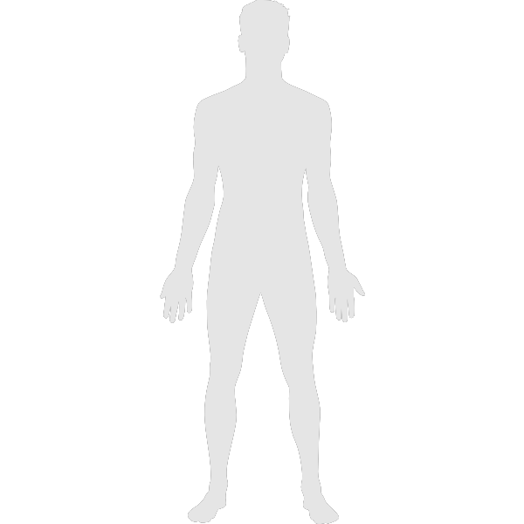
FRONT BACK

Please give more details about your conditions here.

